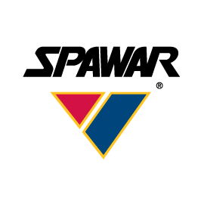

Secure Web Integration Framework

Widget Governance Process

Revision 1.0
16 OCT 2013

Document Change History
Date | Rev. | Description | Author
16 OCT 2013 | 1.0 | Initial revision. | David Magdael

TABLE OF CONTENTS
Secure Web Integration Framework 1
Widget Governance Process 1
1 Introduction 2
2 SWIF Overview 3
3 Information Assurance Approach 4
4 Widget Profiles 5
4.1 Simple 5
4.2 Medium 7
5 Required Involvement & Roles 9
5.1 Developer 9
5.2 SWIF Project Team 9
5.3 Security 9
5.4 Approval Board 10
6 Governance Workflow 11

Introduction
The Secure Web Integration Framework (SWIF) goal is to foster innovation rapidly to field relevant capabilities in order to meet existing and emerging needs of mission planners within a secure, mandatory access control (MAC) environment. Widgets, which are software mobile code developed to provide specific functionality in a web-based environment, provide the technological means to achieve this goal. This document establishes a generic SWIF Widget Governance Process, which can be customized for specific network IA requirements and ensures widgets are efficiently and securely introduced into the SWIF environment.

SWIF Overview
The SWIF Project Team created a number of widgets that work together to provide the ability for Commanders, Planners and Analysts to develop plans, concepts of operations (CONOPS), and analyze potential targets. SWIF is built on top of the OZONE Widget Framework (OWF), version 7.2. For more detailed information, see the SWIF System/Subsystem Design Description (SSDD).
The primary SWIF objectives are as follows:
- Provide a core set of widgets that can be used to support mission planning and target analysis.
- Provide a set of security services that meet PL-3 system requirements for Mandatory Access Control (MAC) and Discretionary Access Control (DAC).
- Allow third parties to use SWIF as a framework for developing, as well as hosting, secure Protection Level 3 (PL-3) widgets to enrich core capabilities.

Data saved to the SWIF repository will require security labeling to ensure data access is based on the user’s security accesses. Access to certain widget types will be role-based to ensure that users are performing appropriate activities related to their duties and functions.

Information Assurance Approach
SWIF intends to leverage existing accreditations for OWF to provide in-depth Information Assurance (IA) defense using known security controls. The information rendered by a widget is made available from the widget run-time hosting environment to the user’s web browser via web or secure web protocols.
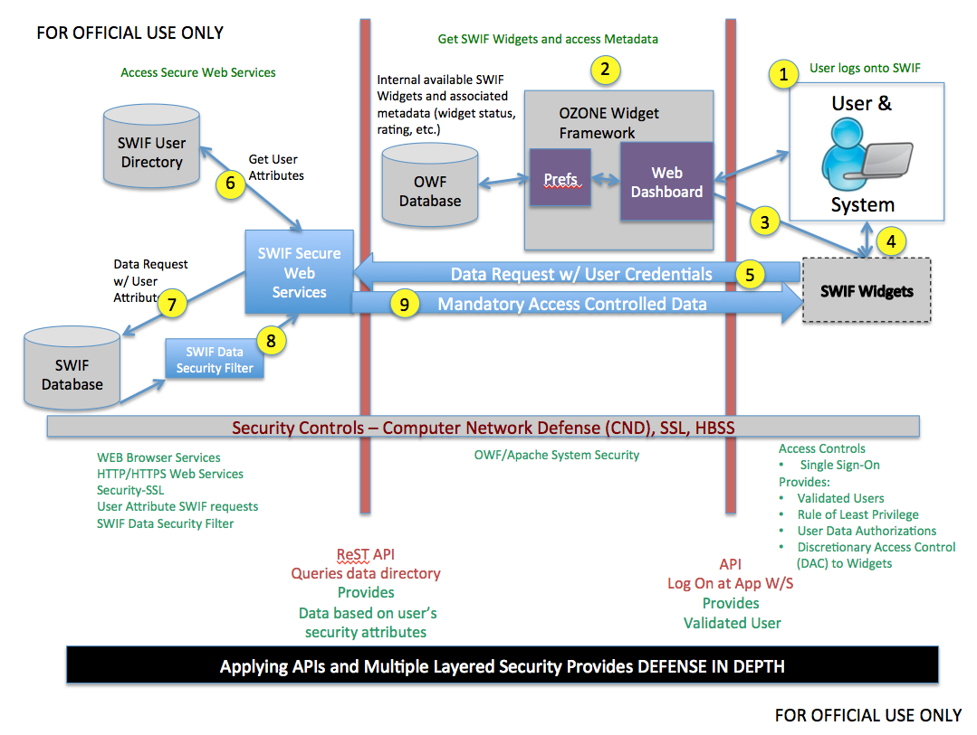
Figure 1 - IA Operational Concept

- User logs onto SWIF via a web browser.
- Within an accredited environment, users are authenticated to SWIF by providing a username and password.
- Role-based DAC SWIF widgets available to user.
- User can select widgets to be rendered using the OWF Dashboard.
- Data request to SWIF Security Services includes user’s credentials.
- User’s security attributes retrieved.
- Data request modified to include user’s security attributes.
- SWIF data security filter double checks returned data to ensure user’s security attributes match data’s security attributes.
- MAC data displayed in SWIF widget.

Widget Profiles
A widget is a dynamic, lightweight web application that users can configure in a variety of ways. Widgets are often a summary or a limited view into a larger web application and can be displayed alongside related widgets. They may operate singularly or as a family of widgets, usually related by purpose, for execution of specific missions. For example, simple single-purpose widgets may be used for chart annotation; while more complex widgets may be used to assist mission workflow.

Widgets are characterized by their capabilities, complexity and security risk posture in relation to networks on which they operate and the applications with which they interface. This section profiles SWIF widgets based on the aforementioned attributes. The following matrix delineates the difference between a simple and medium category type in SWIF:

Widget Type | Renders Data from the SWIF Database | Saves Data to the SWIF Database | Inter-widget Communication
Simple | Yes | Yes | No
Medium | Yes | Yes | Yes

Widget approval is dependent upon the residual risks the widget poses to the network in which it operates and the systems it supports weighed against mission efficiencies, accuracies and overall improvements it creates in specific mission execution.

Simple
The simple category type widget operates exclusively within the client web browser and only interacts with data sources, the Representational State Transfer (REST) application programming interface (API) and SWIF services. A map widget would be an example of a simple categorized widget where the map widget interacts with the REST service to retrieve data from or write data to the SWIF database. No inter-widget communication is allowed between the map widget and any other widgets. The approval process for such a widget, which is subject to change, is accomplished via Memorandum For Record (MFR) depending upon the requirements (e.g. IA) of the network. It undergoes limited testing then is immediately placed in the Approval Process of a widget governance process agenda which will be addressed in a later section. Once approved, the widget is immediately posted for use.

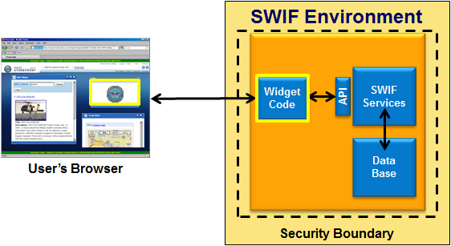
Figure 2 – Simple Widget Security Boundary

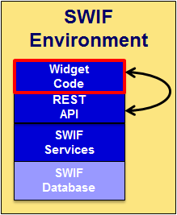
Figure 3 – Simple Widget System View

Medium
The medium category type widget operates exclusively within the client web browser and interacts with data sources, the REST API, SWIF services as well as other widgets. Similar to the simple widget, the medium widget may retrieve data from or write data to the SWIF database. However, the medium widget may also leverage inter-widget communication in order to share information. A widget that plots points within a map widget would be an example of a medium categorized widget. They would undergo the full gamut of testing during a widget governance process agenda which will be addressed in a later section.
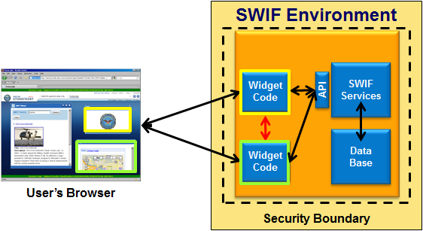
Figure 4 - Medium Widget Security Boundary

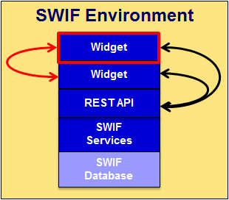
Figure 5 – Medium Widget System View

Required Involvement & Roles
The widget governance process is streamlined into workflows dependent upon the widget’s profile. The Widget Submission Package of medium widgets will undergo a workflow with more rigorous testing and review as compared to simple widgets.

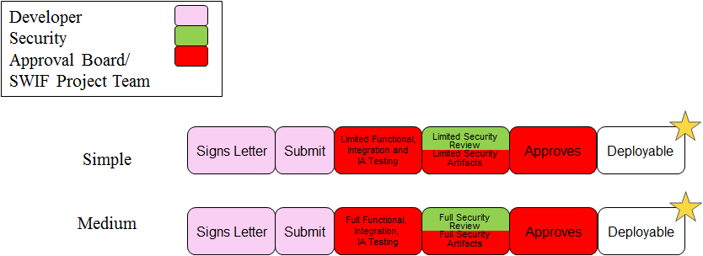
Figure 6 - Widget Characterization Breakout

Developer
The Developer consists of a widget developer and project manager (PM). The widget developer submits the widget and required information to their PM. The PM determines the widget profile according to its capabilities and security boundary and then submits a Widget Submission Package, which includes an MFR, to the SWIF Project Team. The MFR is a signed letter, by the PM, informing the SWIF Project Team that the widget is approved to enter the widget governance process.

SWIF Project Team
The SWIF Project Team consists of personnel to inspect, perform testing and act as an Approval Board. Together they perform the following functions:
- Reviews Widget Submission Packages for completeness.
- Accept Widget Submission Packages for testing.
- Performs limited or full Functional testing.
- Performs limited or full Integration testing.
- Performs limited or full IA testing.
- Provides test results to the Approval Board.
- Approves widgets for deployment.

Security
The SWIF Project Team security responsibilities include performing IA testing. Widgets require varying levels of involvement by security depending on their capabilities and security boundary. A full security review is required for medium profiled widgets as opposed to simple profiled widgets which require a limited security review.

Approval Board
The Approval Board reviews the widget submission package and the test results; then either approves the widget for use, requests additional testing, or requests the Developer rework the widget or provide additional information.

Governance Workflow
The process is streamlined depending upon the input from the Widget Submission Package whose various contents are routed to the appropriate personnel based on role.

- Widgets must meet entrance criteria prior to introduction to the environment.
- Developers must provide the following:
- Source Code
- Descriptive Metadata
- Configuration Documentation
- Testing Results
- IA Documentation
- Points of Contact
- Tests are performed on widgets.
- Widgets are immediately rejected if basic requirements or standards are not met.
- Widgets are approved to be introduced into the environment and are made readily available for testing.
- Widgets pass functional, integration and IA tests.
- Widgets failed a topic and need further testing.
- Widgets are missing material or failed significant portions of testing and need to be reworked.
- Widgets are approved and are made available to the customer.
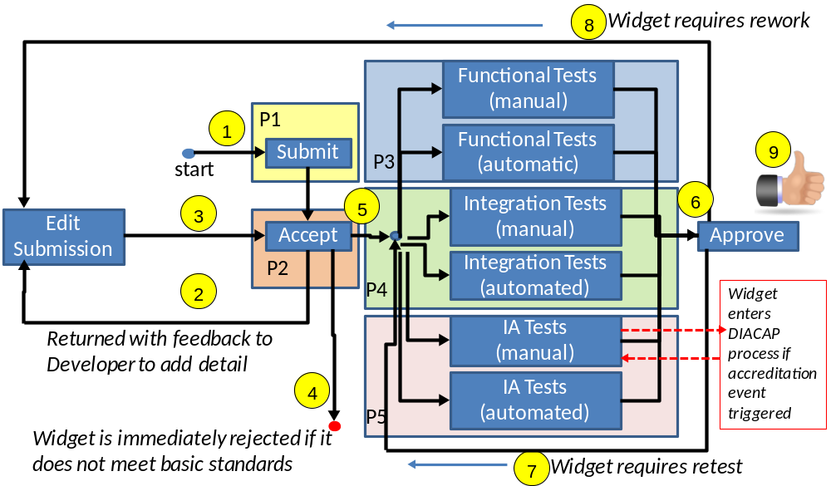
Figure 7 – Detailed Widget Governance Workflow

- A package is submitted by the Developer who is responsible for providing and submitting information.

Figure 8 -– Submission Process
Process (P1): Widget Submission
Process Owner: Developer
Description: The purpose of this process is to ensure that the widget developer and/or PM provides all required information in a Widget Submission Package.
Entry Criteria:  Developer obtains listing of all required widget metadata and documentation for widget acceptance.  Input:  Developer assembles Widget Submission Package, including:  - A one-paragraph description of the widget.  - Additional widget information if available (e.g. user guides, help files, etc.)  - Widget capabilities and security boundaries.  - Widget requirements.  - Installation instructions, if necessary, and source code for services which must be locally available.  - Widget Source Code.  - Documentation software development kit (SDK) that the widget uses.  - Widget binaries.  - An index of the Widget Submission Package.  - Query and save to SWIF services. | Exit Criteria:  Developer has assembled and submitted completed package with all required metadata, widget source code location and data.  Output:  - Developer submits completed Widget Submission Package.  - Widget Submission Package is provided to the SWIF Project Team for approval and assurance of completeness.
Roles:
SWIF Project Team: Provide listing of required widget metadata, documentation and SDK for entry into the Widget Submission Process.
Developer: Provides widget metadata and documentation to the SWIF Project Team.
Assets/References:
DoDI 8552.01 Use of Mobile Code Technologies in DoD Information Systems
Tasks:
1. The SWIF Project Team maintains web accessible listing of required widget metadata and documentation required for the Widget Acceptance Process.
2. Developer fills out required widget metadata and documentation, lists uniform resource locator (URL) for reference information, and attaches files for upload:

Required Widget Information

Metadata Name | Description
Name | Widget name
Type | Widget type
State | Current state of the widget
Release Date | Date of widget release
Categories | Categories to which widget might belong
Installation Instructions URL | URL where installation instructions are located
Screenshot #1 URL | View #1 of widget
Screenshot #2 URL | View #2 of widget
Small Icon URL | Icon goes on corner of widget when launched
Large Icon URL | Icon which shows on Widget Launch Pad
Singleton | Whether or not multiple instances can be launched on the same SWIF dashboard (Y/N)
Visible in Launch Menu | Whether or not widget can be launched in Launch Pad (Y/N)
Recommended Layouts | Recommended display configuration of widget (select from list)
Description | Description of widget function
Use Case(s) | Scenarios describing use of the widget in an operational environment
Sponsor | Sponsor
Owner | Name of widget owner
Technical POC | Name of widget technical POC
Requirements | Computing environment characteristics required for widget operation
Documentation Uploaded | Whether or not documentation has been uploaded (Y/N)
Documentation Location | Document upload location
Version | Widget version number
OWF Framework Compatibility | Compatible OZONE Widget Framework version numbers
Supported Browser(s)

Additional Information Required: Medium Widget

Metadata Name | Description
Inter-widget Producer | Sends inter-widget events (Y/N)
Inter-widget Consumer | Listens for inter-widget events (Y/N)
Inter-widget Communication Formats Name of widget event schemas (synapse, proprietary, etc.) | Name of widget event schemas (e.g. Synapse, proprietary, etc.)
Required Widgets | Other widgets required for this widget to operate
Optional Widgets | Other widgets which may enhance the experience of this widget

3. Developer submits the Widget Submission Package to the Widget Governance Process.
Measures:
The Widget Submission Package is complete, containing all necessary elements to proceed to the Acceptance Process (P2).

- Widgets are rejected if deemed inappropriate for or of little intrinsic value within SWIF.
- The SWIF Project Team reviews the package for completeness. A report of deficiencies is then provided to the Developer who is given the opportunity to edit and correct the issue if the package does not pass acceptance.

Figure 9 - Acceptance Process
Process(P2): Widget Acceptance
Process Owner: SWIF Project Team
Description: The purpose of this process is to verify that the criteria for widget submission to the environment have been met. The SWIF Project Team will conduct the execution of this process.
Entry Criteria:  Completion of Widget Submission Package.  Input:  Inspector receives a Widget Submission Package. | Exit Criteria:  Widget Submission Package is correct and complete.  Output:  Widget is assigned to Functional, Integration and IA testing.
Roles:
Inspector: Designated member of SWIF Project Team who identifies and documents the compliance of entrance material.
SWIF Project Team: Identifies potential non-compliant items and reports findings/status to the Widget Inspector.
Assets/References:
DoDI 8552.01 Use of Mobile Code Technologies in DoD Information Systems
Tasks:
1. Review Widget Submission Package for completeness.
a. Verify all required metadata has been properly filled out.
b. Verify all required items are included.
c. Notify developer if additional information is needed and/or there are missing items that must be provided before the widget is submitted for testing.
2. Verify widget characteristics and boundaries are accurately defined.
a. Review the metadata to ensure the “Description” field describes the widget’s CONOPS and purpose.
b. Review the metadata to ensure the “Recommended Layouts” and “Requirements” fields indicate how to properly operate the widget in a SWIF environment.
c. Notify the developer if there are inaccurate definitions and that they must be addressed before the widget is submitted for testing.
3. Accept Widget Submission Package.

Additional Tasks Required: Medium Widget

1. Review inter-widget descriptions are accurate.
2. Verify required widgets, in order to properly operate, are listed.
3. If applicable, review optional widgets that can be used in conjunction.
4. Notify the developer if there are inaccurate definitions and that they must be addressed before the widget is submitted for testing.
Measures:
Widget Submission Package is complete, containing all necessary elements to proceed to processes P3 through P5.

- Widgets are immediately rejected if basic requirements or standards are not met
- Widget submissions undergo Functional, IA and Integration testing within the environment if the acceptance process is passed. The degree of SWIF Project Team testing is dependent upon widget profile.

Functional, IA and Integration testing are conducted in parallel to the greatest extent possible in order to optimize testing resources and make the process efficient. Tests will be conducted by the SWIF Project Team ensuring a widget suitable for the environment.

Functional testing (P3) focuses on the proper operation of a widget by generating the expected output as described by the developer.

Figure 10 – Functional Test Process

Process (P3): Widget Functional Test
Process Owner: SWIF Project Team
Description: The purpose of this process is to conduct verification of the widget’s functional operation. The execution of this process is primarily conducted by the SWIF Project Team. Collaboration may be required to ensure that the widget is set up properly for testing.
Entry Criteria:  Widget has been accepted for submission.  Input:  A complete and inspected Widget Submission Package. | Exit Criteria:  Independent verification by the SWIF Project Team that widget functions as intended.  Output:  Functional Test Report generated by the SWIF Project Team for inclusion in the Approval Board Package.
Roles:
SWIF Project Team: Performs functional tests.
Tasks:
1. Review Widget Submission Package with respect towards dependencies and execution artifacts.
2. Launch the widget in the dashboard.
a. Verify widget functions with the User Preferences API.
b. If applicable, verify widget functions with the OZONE Drag and Drop API.
c. If applicable, verify widget functions with the OZONE Eventing API.
d. If applicable, verify widget functions with the OZONE Widget Launch API.
e. If applicable, verify widget functions with SWIF Services.
3. Conduct functional tests of the widget within the environment.
a. Validate the functional aspects of the developer’s test plan and report.
b. Verify widget functions as defined in the metadata “Description” field.
4. Complete a Functional Test Report and:
a. Submit report to the Approval Board, or
b. Send the Widget Submission Package to be reworked indicating which functional tests failed and that they must be addressed before the widget is approved from a functional testing aspect.

Additional Tasks Required: Medium Widget

1. Verify required widgets operate properly with widget being tested and vice versa.
2. If applicable, verify optional widgets that can be used in conjunction with widget being tested and vice versa.
3. Complete a Functional Test Report and:
a. Submit report to the Approval Board, or
b. Send the Widget Submission Package to be reworked indicating which inter-widget functional tests failed and that they must be addressed before the widget is approved from a functional testing aspect.

Integration testing (P4) concentrates on widget performance within the environment (e.g. SWIF, identity management solution, etc.) as well as with other widgets.

Figure 11 – Integration Test Process
Process (P4): Widget Integration Test
Process Owner: SWIF Project Team
Description: The purpose of this process is to conduct verification of integration criteria for widget operation in the SWIF environment. The execution of this process is primarily conducted by the SWIF Project Team. Collaboration may be required to ensure that the widget is set up properly for testing.
Entry Criteria:  Widget has been accepted for submission.  Inputs:  A complete and inspected Widget Submission Package. | Exit Criteria:  - All integration tests have been performed by the SWIF Project Team.  - Widget is built using OWF best practices and standards in accordance with (IAW) the SWIF Developer’s Guide.  - Widget works within SWIF environment and does not negatively interfere with other widgets.  - Widget works within SWIF environment and works, as intended and by design, with other widgets.  Outputs:  Integration Test Report generated by SWIF Project Team for inclusion in the Approval Board Package.
Roles:
SWIF Project Team: Performs widget integration tests.
Reference: SWIF Developer’s Guide
Tasks:
1. Review installation and source code then verify that the widget is built IAW The SWIF Developers Guide.
2. Verify the widget is compatible with current SWIF version.
3. Verify interaction and operation compatibility with various browser versions.
a. Review the metadata “Supported Browser(s)” field and verify compatibility with those listed.
b. Verify compatibility with Department of Defense (DoD) standard browsers.
4. Verify the widget does not interfere with other widgets within a SWIF desktop.
. Complete an Integration Test Report and:
a. Submit report to the Approval Board, or
b. Send the Widget Submission Package to be reworked indicating which integration tests failed and that they must be addressed before the widget is approved from an integration testing aspect.

IA testing (P5) ensures data inherit configuration attributes from their accredited parent environments, information is exchanged over a secure channel and that widgets operate in a manner with an acceptable level of security.

The widget will enter the Department of Defense (DoD) IA Certification and Accreditation (C&A) Process (DIACAP) at the direction of the security and return to the widget approval process upon successful completion of DIACAP requirements. Simple and medium widget profiles require varying levels of security approval involvement.

Figure 12 - Information Assurance Process
Process (P5): Widget IA Process
Process Owner: SWIF Project Team
Description: The purpose of this process is to define the major steps required to obtain approval to feature a widget in the dashboard. The execution of this process is primarily conducted by the SWIF Project Team. Collaboration may be required between the Developer submitting the widget and the IA portion of the SWIF Project Team.
Entry Criteria:  Widget has been accepted for submission.  Inputs:  A complete and inspected Widget Submission Package. | Exit Criteria:  All IA evaluations and tests have been performed by the SWIF Project Team.  Outputs:  IA Test Report generated by SWIF Project Team for inclusion in the Approval Board Package.
Roles:
SWIF Project Team: Perform widget IA evaluation.
References:
- DoDI 8552.01, Use of Mobile Code Technologies in DoD Information Systems
- Para 2.3 states: Mobile code that originates from and travels exclusively within a single enclave boundary is exempt from the requirements of this Instruction.
- DoDI 8500.2 Information Assurance (IA) Implementation, February 2003
- Para. E2.1.39. Mobile Code (Definition). Software modules obtained from remote systems,
transferred across a network, and then downloaded and executed on local systems
without explicit installation or execution by the recipient (reference (a), DoD Directive 8500.1 24 Oct 2002).
Tasks:
1. Verify data flow occurs within listed channels.
2. Verify operation occurs within accredited boundaries, protocols and ports.
3. Run and/or verify completion of required security scans IAW The Security Technical Implementation Guide (STIG).
4. Complete an IA Test Report and:
a. Submit report to the Approval Board, or
b. Send the Widget Submission Package to be reworked indicating which IA tests failed and that they must be addressed before the widget is approved from an IA testing aspect.

Additional Tasks Required: Medium Widget

1. Verify DAC / MAC identifies the trustees that are allowed or denied access to the widget.
2. Verify data being used and/or stored within the SWIF environment are pointed to approved paths and/or locations.
3. Complete an IA Test Report and:
a. Submit report to the Approval Board, or
b. Send the Widget Submission Package to be reworked indicating which IA tests failed and that they must be addressed before the widget is approved from an IA testing aspect.

- Upon completion of testing, results will be aggregated and complied for the Approval Board process.

Figure 13 - Approval Process
Process (P6): Widget Approval Board
Process Owner: SWIF Project Team
Description: The purpose of this process is to review the Widget Submission Package for final approval for a widget to be entered. The Approval Board is primarily responsible for this process with assistance from the SWIF Project Team.
Entry Criteria:  Widget has been accepted for submission and has passed all evaluations and tests.  Inputs:  Test reports, including a completed and validated Widget Submission Package, consisting of:  - A one-paragraph description of the widget.  - Additional widget information if available (e.g. user guides, help files, etc.).  - Widget characteristics and boundaries.  - Widget requirements.  - Installation instructions, source code and binaries.  - Documentation SDK that the widget uses.  - An index of the Widget Submission Package. | Exit Criteria:  Widget is approved.  Outputs:  Approval Board package provided for Configuration Management.
Roles:
Approval Board: Reviews test reports and Widget Submission Package; then approves widget has met criteria for deployment.
SWIF Project Team: Assists the Approval Board as required.
Tasks:
1. Review the Widget Submission Package and all test reports.
2. Decides on one of the following courses of action:
a. Order to be reworked by the developer if it contains incorrect detail (e.g. lack of descriptive metadata, wrong references, etc.), or fails testing.
b. Placed in production.
3. If approved, introduce the widget and make it available.
- A widget may also be ordered to be reworked by the Developers if the package contains incorrect detail (e.g. lack of descriptive metadata, wrong references, etc.) which must be corrected prior to deployment to the operational environment.
- A package may be approved, resulting in the widget metadata being placed in the production.

